**CS 4385 - Concurrency and Distributed Systems**

**Project: Dining Philosophers Problem**

**Authors: Jecsan Blanco and Mary (Rachel) Van Pelt**

**Report**: Your project report should discuss details of your logic/functions and how your solution has met/violated the constraints and correctness properties. Any assumptions made, problems encountered, sources referred should all be included in the report  
  
**Assumptions**:  
1. A valid parsable integer will be passed ot the program.

2. Readme instrucitons will be read for program compliation and execution.

**The main programs**

1. **Main** – the main program for the algorithm 6.10
2. **MainV2** – the main program for algorithm 6.11

The main programs are both responsiable for inlsaizaing all the phiosophers and the forks used by the phiosophers, the number of phiosopher depends on the number passed via command line by default the number is set to 5. The main programs are identical besides one is using Phiolsopher for algorithm 6.11

**The Phiosopher class ( threads):**The program reprensents what a phiopher based on the constraints:

• Five philosophers either eat or think - 5 by default or more and have eat and think methods.  
• They must have two forks to eat - forced to wait for left and right forks  
• Can only use forks on either side of their plate - forced to used id and id + 1 forks (left and right)  
• Cannot forcefully obtain a fork (no preemption) – the fork class insurnaces only phiosopher can pick it up.

1. **Phiosopher** - an implementaiton of a phiolsopher using algorithm 6.10
2. **Phiosopher2** - an implementaiton of a phiolsopher using algorithm 6.11

The only diffrence between these two classes is that **Philosopher2** if it is the nth phiopher will  
try to pickup the left fork first instead of the right fork. Since most of the code is the same we untilized class inhernatancce to only change what was needed on **Philosopher2**.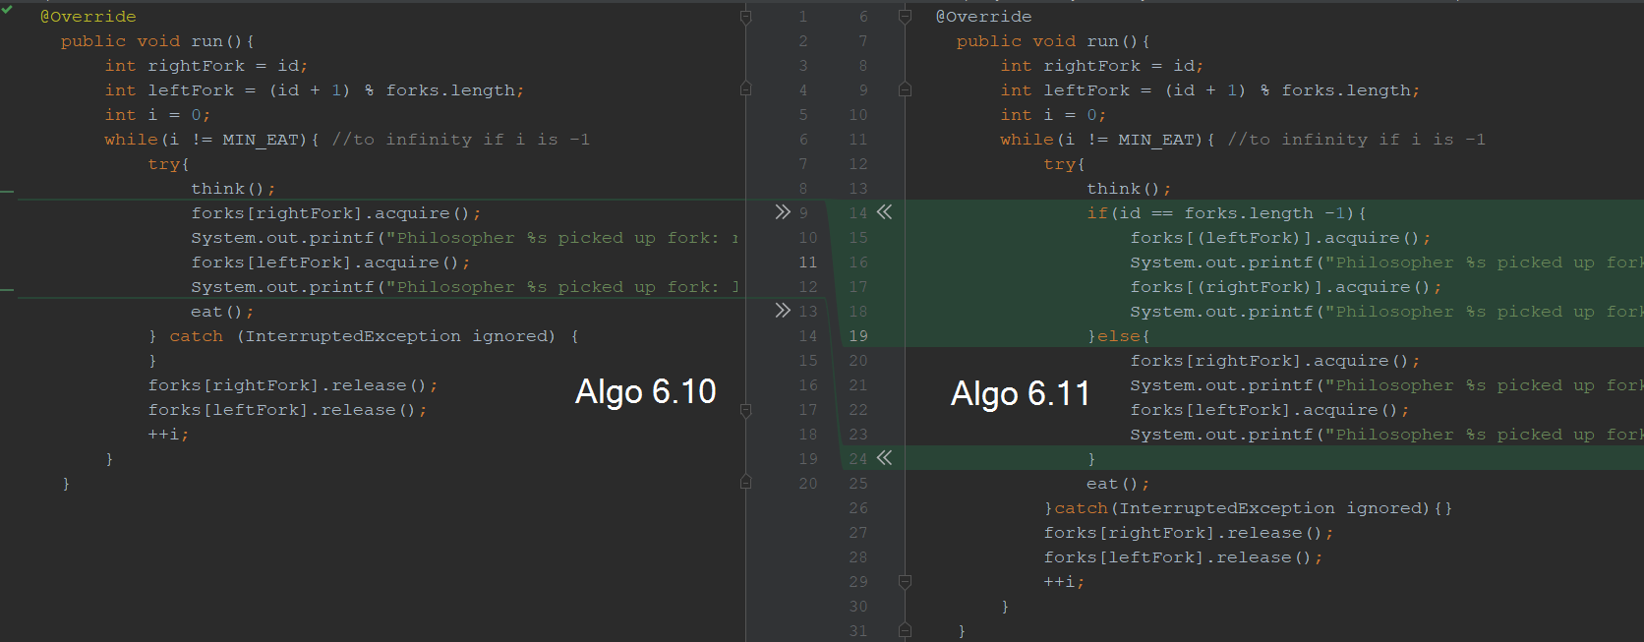

**The Forks class ( semaphores ):**

1. **Fork** – a renamed semaphore so we could use the same terminaolgy as in the problem.

Used for for syznontiation and insurace mutical exlusion between phiosophers, this is just a renamed semaphore.

Problems encountred:

Correctness properties: